|  |  |
| --- | --- |
| EGC_Black | **MATHEMATICS:SPECIALIST 1 & 2 2018**  **TEST 5**  **Calculator Free** |

**Reading time: 2 minutes Time Allowed: 33 minutes**

**Total Marks: 29**

**1. [4 marks]**

Find the equation of the function graphed below:

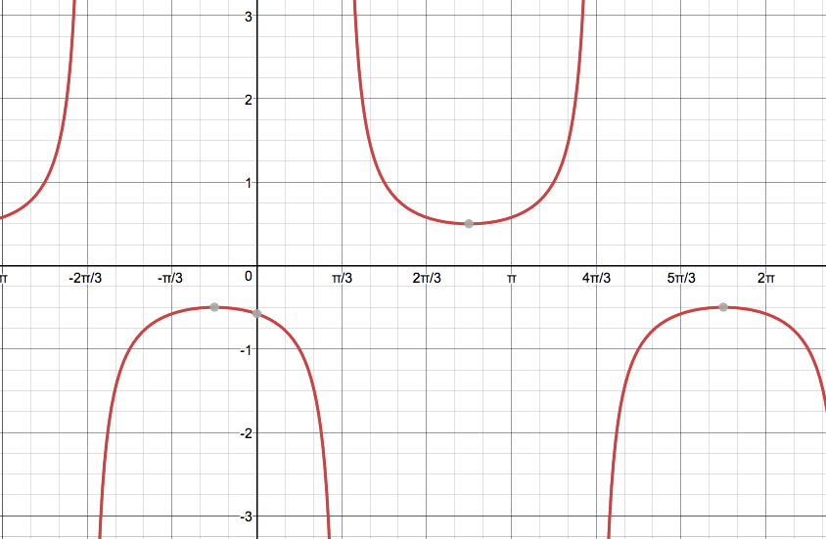

**2. [5 marks]**

Solve the following equation $\sqrt{2}\sec{(x+ \frac{π}{3}} )=-2$, 0 ≤ x ≤ 2π

**3. [3, 3 = 6 marks]**

(a) Draw a sketch of y = cos 2(x - ) 0 ≤ x ≤ 2π

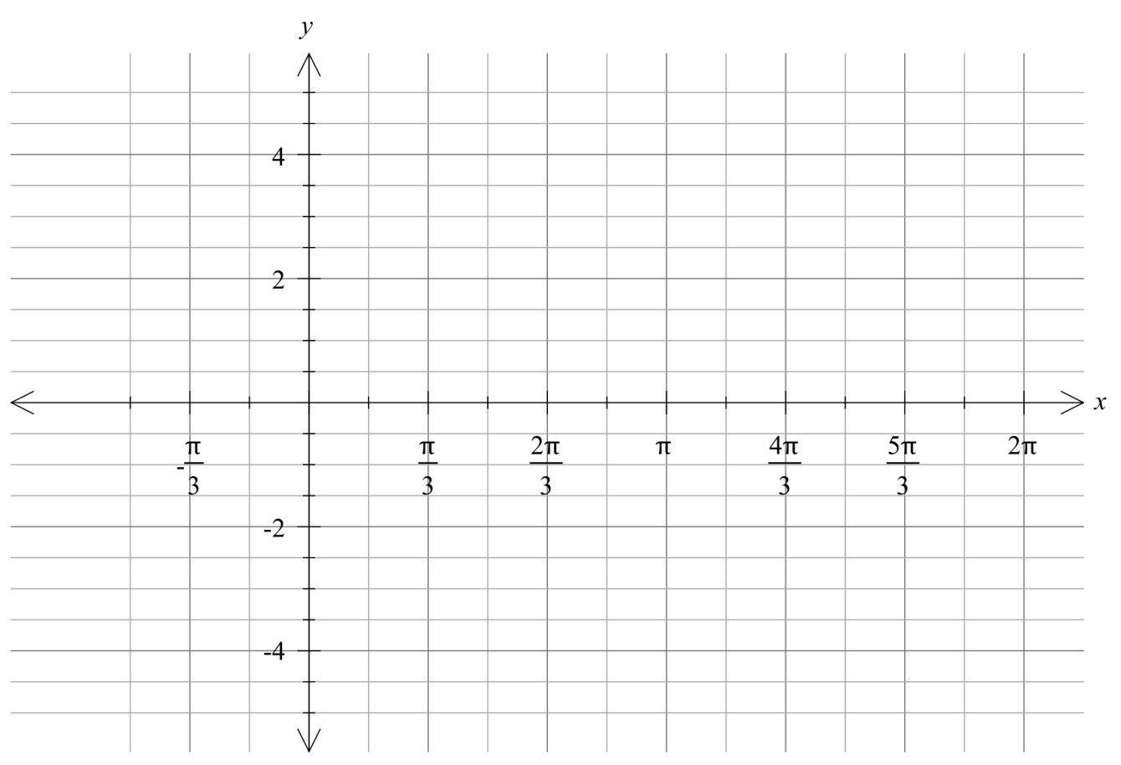

(b) Hence draw a sketch (on the same set of axis as part ‘a’) of y = 2 sec 2(x - ) 0 ≤ x ≤ 2π

**4. [4 marks]**

Prove the identity $\cot{A+\tan{A=\sec{A}\operatorname{cosec}{A}}}$.

**5. [2, 4 – 6 marks]**

(a) Show how to express $5.\overline{25}$ as a rational number. (2 marks)

(b) Prove by contradiction that  is an irrational number. (4 marks)

**6. [2, 2 = 4 marks]**

Find **all** the solutions to the following equations for x in radians

|  |  |
| --- | --- |
| EGC_Black | **MATHEMATICS:SPECIALIST 1 & 2 2018**  **TEST 5**  **Calculator Assumed** |

**Reading time: 2 minutes Time Allowed: 23 minutes**

**Total Marks: 22**

**7. [1, 3, 1 = 5 marks]**

For the sequence **4**, **13**, **22**, **31**, **. . .** ,

(a) Find an expression (in simplest form) for the general term **Tn ,** the nth term, of this sequence.

(b) Prove that the sum of any two consecutive terms of this sequence is always odd.

(c) Use a counter example to disprove that “The sum of any three terms of this sequence is always even.”

**8. [3, 3, 2, 3 = 11 marks]**

The motion of a small body moving along a straight track was recorded by a video camera for 20 seconds. An analysis of the motion showed the distance, *x* cm, of the body from a fixed point *O* on its path *t* seconds after recording began was given by $x\left(t\right)=3cos\frac{πt}{4}-4sin\frac{πt}{4}$.

1. The distance can also be given by $x\left(t\right)=asin⁡(\frac{πt}{4}+b)$, where $a$ and $b$ are real constants.

Determine the values of $a$ and $b$.

1. Graph $y=x(t)$ on the axes below for $0≤t≤20$

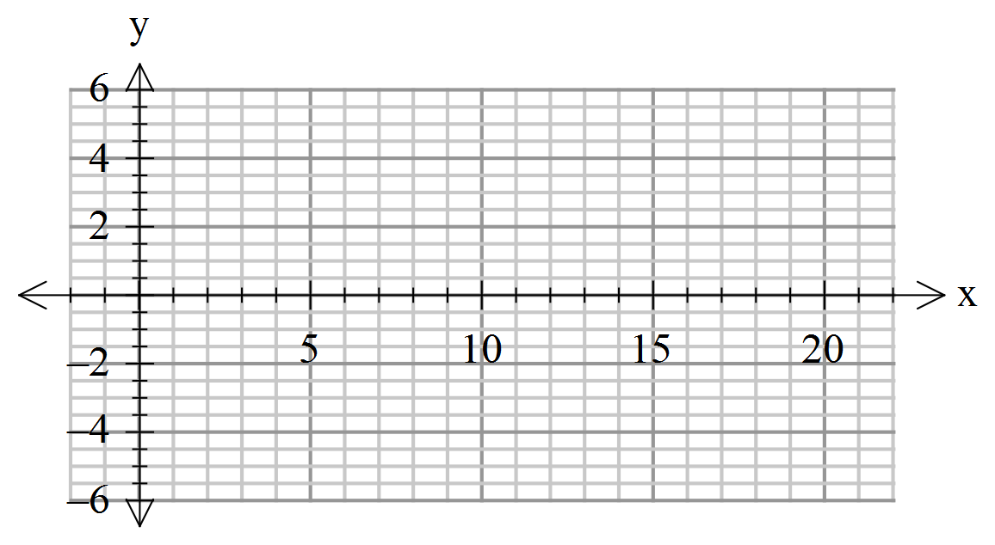

1. State the period and the amplitude of the graph of $y=x(t)$
2. Determine the percentage of the first 20 seconds that the body was at least four cm away from the point *O.*

**9. [ 3, 3 = 6 marks]**

(a) Use an appropriate product-to-sum identity to show that .

(b) Use an appropriate product-to-sum identity to show that the equation below has two

solutions in the domain 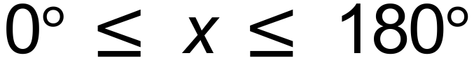. (4 marks)

